**System Requirements Statement (SRS) - iBidPharma**

1. INTRODUCTION ……………………………………………………………………… **3**
2. FUNCTIONAL REQUIREMENTS …………………………………………………… **4**

2.1 MANUFACTURER MODULE…………………………………………………… **6**

2.2 DISTRIBUTOR MODULE ……………………………………………………… **21**

2.3 ADMIN MODULE ……………………………………………………………… **35**

2.4 USE CASE DIAGRAM ………………………………………………………… **40**

THIS DOCUMENT CONTAINS **42** NUMBERED PAGES

# Introduction

This document explains the system requirements and scope for developing Indian Pharmaceutical Bidding System hereby mentioned as iBidPharma System.

iBidPharma System could divide into the three main parts : Manufacturer part, Distributor part and Admin part.

This document describes the system requirement of the Account part.

# Functional Requirements

The Account part of iBidPharma System has three modules which are divided into 13 processes described as below.

|  |  |  |
| --- | --- | --- |
| **Sr. No.** | **BRS Requirement ID** | **Description** |
| 2.1 | Manufacturer Module | |
| 2.1.1 | F1 | Account Creation Process |
| 2.1.2 | F2 | Login Process |
| 2.1.3 | F3 | Forget Password Process |
| 2.1.4 | F4 | Change Password Process |
| 2.1.5 | F5 | Update Account Process |
| 2.1.6 | F6 | Publish Product for Bidding |
| 2.1.7 | F7 | Update Product Information |
| 2.1.8 | F8 | Delete Product |
| 2.1.9 | F9 | Choose Best Bid |
| 2.1.10 | F10 | Search Distributor |
| 2.1.11 | F11 | View Order History |
| 2.1.12 | F12 | Report Generation |
| 2.2 | Distributor Module | |
| 2.2.1 | F13 | Account Creation Process |
| 2.2.2 | F14 | Login Process |
| 2.2.3 | F15 | Forget Password Process |
| 2.2.4 | F16 | Change Password Process |
| 2.2.5 | F17 | Update Account Process |
| 2.2.6 | F18 | Search Products Listings |
| 2.2.7 | F19 | Bid on Product |
| 2.2.8 | F20 | Cancel Bid |
| 2.2.9 | F21 | Browse Existing Placed Bids |
| 2.2.10 | F22 | Search Manufacturer |
| 2.2.11 | F23 | View Transaction History |
| 2.2.12 | F24 | Report Generation |
| **Sr. No.** | **BRS Requirement ID** | **Description** |
| 2.3 | Admin Module | |
| 2.3.1 | F25 | Login Process |
| 2.3.2 | F26 | Change Password Process |
| 2.3.3 | F27 | Update Account Process |
| 2.3.4 | F28 | Report Generation |
| 2.3.5 | F29 | Account Management |
| 2.3.6 | F30 | Revenue Management |

# Manufacturer Module

* Manufacturer is the user of the system who wants to sell his product through bidding.
* He is also able to view the currently placed bids on the product.

**2.1.1 Account Creation Process**

* iBidPharma System compels to create the account before using it. So iBidPharma System should provide the function which makes Manufacturer creates new account.
* For every manufacturer account creation, iBidPharma System is charging ₹500.
* When Manufacturer creates new account, the function demands two information described as below.

1. Login Information
2. Contact Details
3. Security Question Information

#### The Login Information

The Login Information consists of some items described as below.

1. User ID
2. Password
3. Company Name
4. User Type
   * All items are compulsory demanded.
   * User ID

* The User ID should be unique. If the User ID correspond with not case-sensitive to other which is previously registered, the User ID should not be registered as an account.
  + Password
* The Password has constrains which makes the Password consists of more than or equal 8 and less than or equal 16 characteristics including characters described as below.

1. Numeric figure (at least one)
2. Capital alphabet (A-Z)(at least one)
3. Small alphabet (a-z)(at least one)
4. Special character (#, $, %, &, etc.) (at least one)

* The Password is masked by dummy characters. The re-entering Password is demanded.
* The Password must be encrypted in iBidPharma System.
  + Company Name
* The Company Name should be unique.
  + User Type

The User Type falls into three categories described as below.

1. Manufacturer
2. Distributor
3. Administrator

* The User Type defines also three types of user; "Manufacturer user", "Distributor user", and "Administrator user”.
* In an Account Creation Process, the user can select Manufacturer.
* No one could select The Administrator, because Administrator is implemented to of iBidPharma System in advance.

# Contact Details

The Contact Details consists of some items described as below.

1. Permanent Address
2. Contact Number
3. E-mail Address
4. Location
   * All items are compulsory demanded.
   * Permanent Address

* Permanent Address should be filled.
  + Contact Number
* Contact Number should be filled.
* Contact Number should be unique.
  + E-mail Address
* E-mail Address should be filled.
* E-mail Address should be in proper format.
* E-mail Address should be unique.
  + Location
* Location should be filled.
* Only the state should be selected from options.

# 3. The Security Question information

The Security Question information is needed when manufacturer lost their Password. This information consists of two items described as below.

1. Selected Question
2. Answer
   * All items are compulsory demanded.
   * Some questions which are difficult to answer for anyone else are prepared in advance.

Ex. Which color do you like most ?

* + A question should be selected from options by the manufacturer and the Answer is registered by the manufacturer.
* Login information should be entered on one screen, and then manufacturer information and Security Question information should be entered on another screen.

**2.1.2 Login Process**

* iBidPharma System always compels user authentication before using itself.
* The user authentication demands User ID and Password. The User ID and the Password should be checked in three ways.
  + First, The User ID and the Password should be existed and correct.
* If The User ID and the Password are not equal to what the user has registered, the user authentication cannot be provided.
  + Second, the User Type linked to the User ID should be "Manufacturer".
* When the User Type is "Manufacturer", then user can be placed on “Manufacturer Home”.
  + Finally, User ID should be available.
* The Administrator can decide whether the User ID is available or suspended – Refer to the SRS of the Admin part.
* If manufacturer is rejected, user authentication is not provided for system user.
* Only when the three checks are successfully completed, manufacturer can be placed on respected page.
* The “Manufacturer Home” provides the some items described as below.

1. A trigger to Logout
2. A trigger to Update Account
3. A trigger to Change Password
4. A trigger to Product Listing
5. A trigger to Publish Product for sale
6. A trigger to Update Product Information
7. A trigger to Delete Product
8. A trigger to Browse Existing Bids on Product Listing
9. A trigger to Select Best Bid
10. A trigger to Search Distributor
11. A trigger to View Order History
12. A trigger to Report Generation

**2.1.3 Forgot Password Process**

* When system user lost their Password, the recovery method should be provided by iBidPharma System.

The recovery method is described as below.

* + First, System user enters their User ID for iBidPharma System.
  + Next, iBidPharma System demands the Answer which has been registered since when the Account was created.
  + Only when the Answer is correct, manufacturer get the new password by E-mail which also has been registered since when the Account was created.
  + The new password is automatically generated by iBidPharma System.
* Of course, the new password should consist of more than or equal 8 and less than or equal 16 characteristics including at least a numeric figure, a capital alphabet, a small alphabet, and a special character.
* As a consequence, The Manufacturer could get the manufacturer authentication using the new password.
  + Then, the manufacturer had better change the new password manually.
* If the Answer is not correct, otherwise, the correct Answer is demanded for user again.
  + In that case, Of course, manufacturer couldn’t get the new password.

### 2.1.4 Change Password Process

* When manufacturer wants to change their Password, the measure should be provided by iBidPharma System.
* Therefore, iBidPharma System should provide the function which is available after getting the manufacturer authentication.
* The function demands the current password and the new password.
  + Of course, the new password should consist of more than or equal 8 and less than or equal 16 characteristics including at least a numeric figure, a capital alphabet, a small alphabet, and a special character.
  + The current password and the new password are masked by using dummy characters.
  + The new password is demanded to enter twice to avoid a typing error.
* Only when the current password is correct, manufacturer could change their Password.
* When the current password is changed into new password, iBidPharma System compels user authentication again.

### 2.1.5 Update Account Process

* iBidPharma System should provide the function which makes the account updated for manufacturer.
* The information, Manufacturer could update is described below.

1. Login information
2. User information
3. Security Question Information
4. **The Login information**

The updatable items as described below.

1. Company Name
   * All items are compulsory demanded, but updating is optional.
2. **The User information**

The updatable items as described below.

1. Contact Number
2. Permanent Address
3. E-mail Address
4. Location
   * All items are compulsory demanded, but updating is optional.
5. **Security Question Information**

The updatable items as described below.

1. Selected Question
2. Answer
   * All items are compulsory demanded, but updating is optional.

### 2.1.6 Publish Product for Bidding

* iBidPharma System should provide the function to publish product for Bidding .So that ,Distributors can check the available product listing provided by Manufacturer and Bid on desirable products.
* Before publishing products , it is mandatory for manufacturer to fill the following categories.
* The categories are described below.
* Product Category
* Manufacturer can choose the product category ( i.e. Vaccine, Tablet, Syrup , etc.) and add the product in specific category, before publishing the product So that the distributor can have a look on the product list and bid on the products.
* Bidding Range
* Manufacturer have to select Bidding range before publishing the product
* It must be number. No characters , special characters are allowed.
* Product Name
* Manufacturer should be able to add different products in the system.
* Product Name has to be in character format only.
* Stock
* Before publishing the product Manufacturer has to select the quantity of product
* It should be number formal only.
* No characters , special characters are allowed.
* Deliverable Locations
* Manufacturer has to select location before publishing products at which it will be available.
* It should be in character format only.
* Product Image
* Manufacturer can put the image of the specific product if he wish.

### 2.1.7 Update Product Information

* After publishing the product the manufacturer can only update following contents.

1. Stock
2. Production per Day
3. Deliverable Locations

* Stock

Manufacturer should update the availability of each product in database. which will automatically be reflected in the product list table which is visible to both manufacturer and distributors.

* Production per Day

Manufacturer can update the production of per day of each product. After updating the production per day it will be reflected in the product list table. All changes will be visible to manufacturer and distributor both.

* Deliverable Locations

If manufacture can deliver products to new location or if he can not deliver to the location provided previously by him then he can update deliverable locations. After updating deliverable location , changes will be reflected in the product list table.

### 2.1.8 Delete product information

If manufacturer wants to remove any product which is not available then iBidPharma system provides the functionality “Delete Product Information” which will remove the product from product list.

* Only manufacturer can delete any product from the list.
* After Deleting the product , Product details will be removed from database completely.
* Updated list will be to distributor and manufacturer.

### 2.1.9 Choose Best Bid

* The number of distributors have placed bids on the various products provided by manufacturer for the quantity of products distributor wants at particular location and time.
* Now, the manufacturer can choose best bid and will fulfill the distributor’s order requirements.
* To choose best bid manufacturer can apply different filters.
* Filters are described below.

1. Bid Price

* Manufacturer will be able to see an option “Bid Price” on the system. He can enter the bid price of his choice. As soon as he enters some price he will be able to see the number of products with bid at that price and above. So he can choose the best bidding price accordingly.
* The bidding price entered by the manufacturer must be in the range he have set for bidding
* It should be in number format only.

1. Stock

* If the manufacturer enters “Quantity” option on the system he can see for how much quantity the distributors have placed bids on some products.
* It should be in number format only.
* Characters and special characters are not allowed.

1. Delivery Date

* The manufacturer can choose the delivery date by clicking on the option “Delivery Date”. When the manufacturer enters this he can see the dates of current month. As he chooses a particular date, he can see different bids placed by the distributors on that date.

1. Location

* The manufacturer also have one more option on the system to choose best bid of the products which is “Location”. When manufacturer selects this option he can enter the location or select the location from the list provided in the system. The manufacturer can choose the best bid on that location.

**2.1.10 Search Distributor**

* The manufacturer can also search for the distributors using iBidPharma bidding system.
* The system provides two options under “Search Distributor”; which are as follows.

1. Location

* If distributor enters a proper location i.e. Area name, then all manufacturers from that particular area will be populated in a list.
* If no distributors are present in that area, a message no records found will be displayed.

1. Distributor Name

* Manufacturer can search distributor by Distributor’s Company name. If entered company name is available in the list provided in the iBidPharma system then details of that distributor will be populated.
* If Distributor with the given name is not found a message no records found will be displayed.

### 2.1.11 View Order History

* Manufacturer can access the record of all the successful transactions performed by him. He can have track on all transactions and order details in transaction history page History the manufacturer can see the several options sliding down which are described below using which he can access the record of all successful orders.

1. Transaction Date

* This specifies the date of transaction/date of order when he completed all the necessary requirements to final the order.

1. Product Category

* This specifies the product category.

1. Product Name

* This specifies the product name, on which the order is placed.

1. Bidding Price of Product

* Bidding Price is the price that the Distributor has placed the bid.

1. Details of Manufacturer

* The details of the Manufacturer such as Name of Manufacturer and Location will be provided.

1. Product Quantity

* This shows the total quantity of the product they ordered.

1. Expected Delivery Date

* This shows the expected date given by the Manufacturer for the product ordered, has to be delivered.

1. Delivery Location

* This shows the location in which the order has to be delivered and provided by the Distributor.

### 2.1.12 Report Generation

* Manufacturer can generate reports of his order history. Report Generation conditions are described as follow.

1. Product Name

* Manufacturer can view only the list of products which he ordered and Report Details will be transaction history of that specific product location.

2. Location

* Report Details will be transaction history on that specific location from from where the order was placed.

# Distributor Module

* Distributor is the user of the system who wants his product to get bid.
* He is also able to view the currently listed products for bidding.
  + 1. **Account Creation Process.**
* iBidPharma System compels to create the account before using it. So iBidPharma System should provide the function which makes Distributor creates new account.
* For every distributor account creation, iBidPharma System is charging ₹500.
* When Distributor creates new account, the function demands two information described as below.

1.Login Information

2. Contact Details

3. Security Question Information

#### The Login Information

The Login Information consists of some items described as below.

1. User ID
2. Password
3. Company Name
4. User Type
   * All items are compulsory demanded.
   * User ID

* The User ID should be unique. If the User ID correspond with not case-sensitive to other which is previously registered, the User ID should not be registered as an account.
  + Password
* The Password has constrains which makes the Password consists of more than or equal 8 and less than or equal 16 characteristics including characters described as below.

1. Numeric figure (at least one)
2. Capital alphabet (A-Z)(at least one)
3. Small alphabet (a-z)(at least one)
4. Special character (#, $, %, &, etc.) (at least one)

* The Password is masked by dummy characters. The re-entering Password is demanded.
* The Password must be encrypted in iBidPharma System.
  + Company Name
* The Company Name should be unique.
  + User Type

The User Type falls into three categories described as below.

1. Manufacturer
2. Distributor
3. Administrator

* The User Type defines also three types of user; "Manufacturer user", "Distributor user", and "Administrator user”.
* In an Account Creation Process, the user can select Distributor.
* No one could select The Administrator, because Administrator is implemented to of iBidPharma System in advance.

# Contact Details

The Contact Details consists of some items described as below.

1. Permanent Address
2. Contact Number
3. E-mail Address
4. Location
   * All items are compulsory demanded.
   * Permanent Address

* Permanent Address should be filled.
  + Contact Number
* Contact Number should be filled.
* Contact Number should be unique.
  + E-mail Address
* E-mail Address should be filled.
* E-mail Address should be in proper format.
* E-mail Address should be unique.
  + Location
* Location should be filled.
* Only the state should be selected from options.

# 3. The Security Question information

The Security Question information is needed when distributor lost their Password. This information consists of two items described as below.

1. Selected Question
2. Answer
   * All items are compulsory demanded.
   * Some questions which are difficult to answer for anyone else are prepared in advance.

Ex. What is your pet name ?

* + A question should be selected from options by the distributor and the Answer is registered by the distributor.

Login information should be entered on one screen, and then distributor information and Security Question information should be entered on another screen.

* + 1. **Login Process**
* iBidPharma System always compels user authentication before using itself.
* The user authentication demands User ID and Password. The User ID and the Password should be checked in three ways.
  + First, The User ID and the Password should be existed and correct.
* If The User ID and the Password are not equal to what the user has registered, the user authentication cannot be provided.
  + Second, the User Type linked to the User ID should be "Distributor".
* When the User Type is "Distributor", then user can be placed on “Distributor Home”.
  + Finally, User ID should be available.
* The Administrator can decide whether the User ID is available or suspended – Refer to the SRS of the Admin part.
* If manufacturer is rejected, user authentication is not provided for system user.
* Only when the three checks are successfully completed, distributor can be placed on respected page.
* The “Distributor Home” provides the some items described as below.

1. A trigger to Logout
2. A trigger to Update Account
3. A trigger to Change Password
4. A trigger to Search Product Listing
5. A trigger to Place Bid on Product
6. A trigger to Cancel Bid
7. A trigger to Browse Existing Placed Bids
8. A trigger to Search Manufacturer
9. A trigger to View Transaction History
10. A trigger to Report Generation
    * 1. **Forget Password Process**

* When system user lost their Password, the recovery method should be provided by iBidPharma System.

The recovery method is described as below.

* + First, System user enters their User ID for iBidPharma System.
  + Next, iBidPharma System demands the Answer which has been registered since when the Account was created.
  + Only when the Answer is correct, distributor get the new password by E-mail which also has been registered since when the Account was created.
  + The new password is automatically generated by iBidPharma System.
* Of course, the new password should consist of more than or equal 8 and less than or equal 16 characteristics including at least a numeric figure, a capital alphabet, a small alphabet, and a special character.
* As a consequence, The Distributor could get the distributor authentication using the new password.
  + Then, the distributor had better change the new password manually.
* If the Answer is not correct, otherwise, the correct Answer is demanded for user again.

In that case, Of course, distributor couldn’t get the new password.

* + 1. **Change Password Process**
* When distributor wants to change their Password, the measure should be provided by iBidPharma System.
* Therefore, iBidPharma System should provide the function which is available after getting the distributor authentication.
* The function demands the current password and the new password.
  + Of course, the new password should consist of more than or equal 8 and less than or equal 16 characteristics including at least a numeric figure, a capital alphabet, a small alphabet, and a special character.
  + The current password and the new password are masked by using dummy characters.
  + The new password is demanded to enter twice to avoid a typing error.
* Only when the current password is correct, manufacturer could change their Password.
* When the current password is changed into new password, iBidPharma System compels user authentication again.
  + 1. **Update Account Process**
* iBidPharma System should provide the function which makes the account updated for distributor.
* The information, Distributor could update is described below.

1. Login information
2. User information
3. Security Question Information
4. **The Login information**

The updatable items as described below.

1. Company Name
   * All items are compulsory demanded, but updating is optional.
2. **The User information**

The updatable items as described below.

1. Contact Number
2. Permanent Address
3. E-mail Address
4. Location
   * All items are compulsory demanded, but updating is optional.
5. **Security Question Information**

The updatable items as described below.

1. Selected Question
2. Answer
   * All items are compulsory demanded, but updating is optional.
     1. **Search Product Listings**

* iBidPharma System should provide the functionality of searching desirable product from the all product listings.
* Distributor can apply multiple filters to get best suitable product listing.
* Search conditions are described as below.

1. Product Category

* Distributor can choose product category (i.e. Vaccine, Tablet, Syrup etc.). Only those products will be displayed who belong to selected product category.

1. Bidding Range

* Distributor can choose bidding range (i.e. minimum bid value, maximum bid value). Only those products will be displayed who fall under selected bidding range.

1. Stock

* Distributor can choose available stock. Only those products will be displayed who’s stock is greater than or equal to selected stock.

1. Deliverable Location

* Distributor can choose delivery location. Only those products will be displayed who has selected location in their deliverable locations.
  + 1. **Place Bid on Product**
* iBidPharma System should provide the function to place a bid on desirable product listing from the all product listings.
* Distributor can apply place multiple bids on multiple product listings.
* Place Bid requirements are described as below.

1. Product Category

* Distributor should not be able to modify product category neither He need to manually select product category.
* Category should match with selected manufacturer’s product listing category.
* Category must exist in available product categories from database.

1. Product Name

* Distributor should not be able to modify product name neither He need to manually enter product name.
* Name should match with specific manufacturer’s product listing name.

1. Bidding Price

* Distributor should enter bidding price for the specific product listing.
* Must be number. No characters, special characters are allowed.
* Price should be greater than or equal to specific manufacturer’s product bidding minimum value and Price should be less than or equal to specific manufacturer’s product bidding maximum value.

1. Stock

* Distributor should enter required stock for the specific product listing.
* Must be number. No characters, special characters are allowed.

1. Expected Delivery Date

* Distributor should enter choose expected delivery date for the specific product listing.
* Must be greater than today’s date.

1. Delivery Location

* Distributor should select delivery location from the specific product listing’s deliverable locations.
* Must exist in available locations from database.
  + 1. **Cancel Bid**
* iBidPharma System should provide the function to cancel already placed bid on product listing.
* Distributor can not cancel bid which is selected by manufacturer as best bid for that specific product listing.
* Distributor can anytime browse existing placed bids and cancel any number of bids from existing bids.
  + 1. **Browse Existing Placed Bids**

* iBidPharma System should provide the functionality to browse already placed bid on product listing.
* Bids which are selected as best bid by manufacturer should not be listed in existing placed bids.
* Those Bids whose transaction is complete should not be listed here.
* Cancel bid option is available for every existing placed bid which doesn’t fall under the above two circumstances.
  + 1. **Search Manufacturer**
* Distributor can search for manufacturer directly through the search bar. This will save the time of Distributor if they wanted to bid for known Distributor or Distributors from a particular area.
* Search conditions are described below.

1. Location

* If distributor enters a proper location i.e. Area name, then all manufacturers from that particular area will be populated in a list.
* If no distributors are present in that area, a message no records found will be displayed.

1. Distributor Name

* Distributor can search directly by Distributor’s Company name. If following distributor is present then details of that distributor will be populated else suggestion will be given if similar name is found.
* If Distributor with the given name is not found a message no records found will be displayed.
  + 1. **View Transaction History**
* Distributor can access the record of all the successful transactions performed by him. He can have track on all transactions and order details with him in transaction history page.
* Record Details are described below.

1. Transaction Date

* This specifies the date of transaction/date of order when he completed all the necessary requirements to final the order.

1. Product Category

* This specify the product category.

1. Product Name

* This specify the product name, on which the order is placed.

1. Bidding Price of Product

* Bidding Price is the price that the Distributor has placed the bid.

1. Details of Manufacturer

* The details of the Manufacturer such as Name of Manufacturer and Location will be provided.

1. Product Quantity

* This shows the total quantity of the product they ordered.

1. Expected Delivery Date

* This shows the expected date given by the Manufacturer for the product ordered, has to be delivered.

1. Delivery Location

* This shows the location in which the order has to be delivered and provided by the Distributor.
  + 1. **Report Generation**
* Distributor can generate reports of his transaction history. Report Generation conditions are described as follow.

1. Product Name

* Distributor can view only the list of products which he ordered and Report Details will be transaction history of that specific product.

1. Location

* Report Details will be transaction history on that specific location from which he ordered products.

# Admin Module

Administratorshould be responsible for following activities.

1. Account Management
2. Revenue Management
3. Report Generation
   * 1. **Login Process**

* iBidPharma System always compels user authentication before using itself except when a new account is successfully created.
* The user authentication demands User ID and Password. The User ID and the Password should be checked in three ways.
  + First, The User ID and the Password should be existed and correct.
* If The User ID and the Password are not equal to what the admin has registered, the Admin authentication cannot be provided.
  + Second, the User Type linked to the User ID should be "Administrator".
* When the User Type is "Administrator", user can be placed on “Admin Home”.
  + Finally, User ID should be available.
* The Administrator can decide whether the User ID is available or suspended.
* If user is rejected, user authentication is not provided for system user.
* The Admin account should alive for so long as the duration decided by Administrator.
* Only when the three checks are successfully completed, Admin can be placed on respected page.
* The “Administrator Home” provides the some items described as below.

1. A trigger to Logout
2. A trigger to Update Account
3. A trigger to Change Password
4. A trigger to View Successful Transactions
5. A trigger to Report Generation
6. A trigger to View Revenue Management
   * 1. **Change Password Process**

* When Admin wants to change his Password, the measure should be provided by iBidPharma System.
* Therefore, iBidPharma System should provide the function which is available after getting the Administrator authentication.
* The function demands the current password and the new password.
  + Of course, the new password should consist of more than or equal 8 and less than or equal 16 characteristics including at least a numeric figure, a capital alphabet, a small alphabet, and a special character.
  + The current password and the new password are masked by using dummy characters.
  + The new password is demanded to enter twice to avoid a typing error.
* Only when the current password is correct, Admin could change his Password.

When the current password is changed into new password, iBidPharma System compels user authentication again.

* + 1. **Update Account Process**
* iBidPharma System should provide the function which makes the account updated for Admin.
* The information Admin could update is described below.

1. Login information
2. User information

**1. The Login information**

The updatable items as described below.

1. E-mail address
   * All items are compulsory demanded, but updating is optional.

**2. The User information**

The updatable items as described below.

1. Admin Name
2. Contact Number
3. Permanent Address
4. Location
   * All items are compulsory demanded, but updating is optional.
     1. **Report Generation**

* Admin should able to see all the successful order details of the manufacturers and the distributors, transaction details. And can generate reports for the same. Report Generation conditions are described as follow.

1. Manufacturer

* Report Details will be order history of that specific manufacturer name which is searched by the admin. Admin can view all the transactions that the manufacturer completed with different distributors.

1. Distributor

* Report Details will be transaction history of that specific distributor name which is searched by the admin. Admin can view the product details and details of manufacturer from which it has been ordered.

1. Product Name

* Report Details will be order history for that specific product. It will give the information of the distributor who placed bid on the product and the manufacturer who delivered the product successfully.

1. Location

* Report Details will be order history on that specific location. It will show the information of the distributor and the manufacturer who placed and delivered the product and completed transaction successfully in that location.

* + 1. **Account Management**
* Admin should able to authorize and manage all the accounts with following activities.
* After all the process of registering of manufacturer and distributor admin will authenticate them from his side and enable or disable the account creation request.

1. Enable accounts

* Admin will enable the user if all process has been competed successfully by both side and allow user to use the website.

1. Disable accounts

* Admin can Disable account if any fault or fraud practices has occurred by the user.
  + 1. **Revenue Management**
* Admin can able to see the revenue generated from the successful user registrations.
* Revenue Generation conditions are described below.

1. Month

* Revenue Details will be successful user registrations in that specific Month.

1. Location

* Revenue Details will be successful user registrations from that specific Location.

# Use Case Diagram

**Manufacturer :**

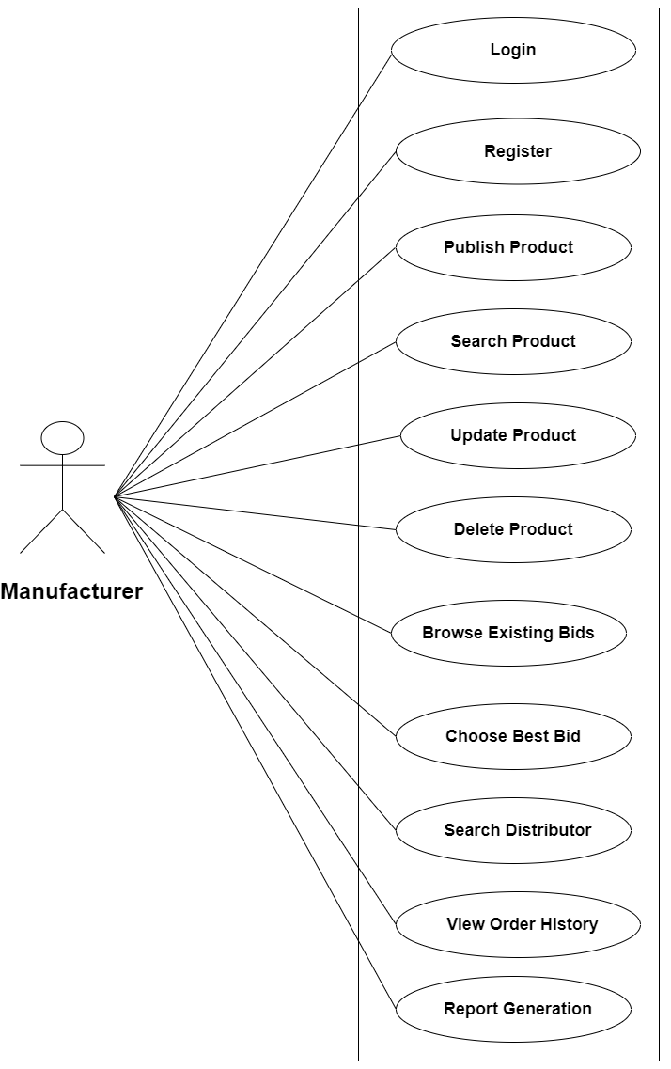

*Fig. Use Case Diagram for Manufacturer*

1. In Manufacturer use case diagram Manufacturer is the Actor.
2. Manufacturer can handle following use cases:
3. Login
4. Register
5. Publish Product
6. Search Bid
7. Update Product
8. Delete Product
9. Browse Existing Bids
10. Choose Best Bid
11. Search Distributor
12. View Order History
13. Report Generation

**Distributor :**

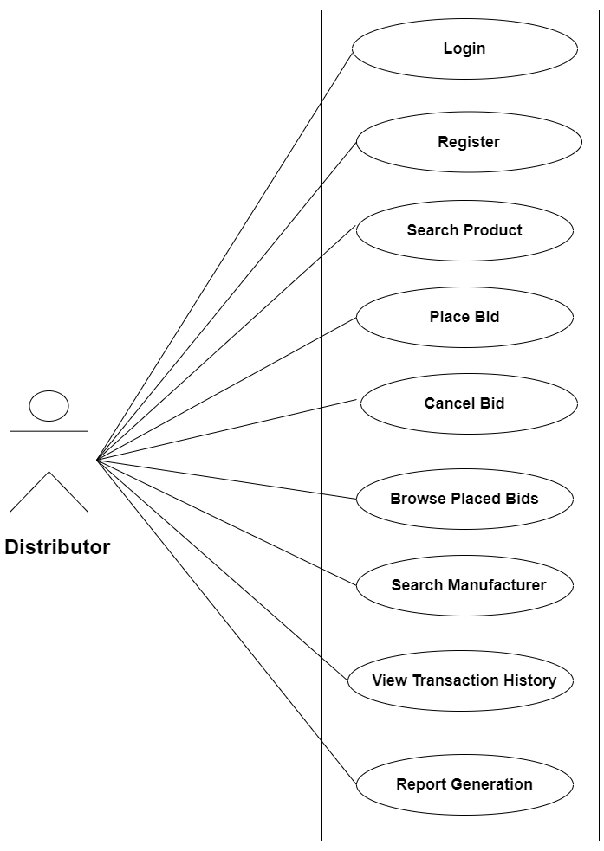

*Fig. Use Case Diagram for Distributor*

1. In Distributor use case diagram Distributor is the Actor.
2. Distributor can handle following use cases:
3. Login
4. Register
5. Search Product
6. Place Bid
7. Cancel Bid
8. Browse Placed Bids
9. Search Manufacturer
10. View Transaction History
11. Report Generation

**Admin :**

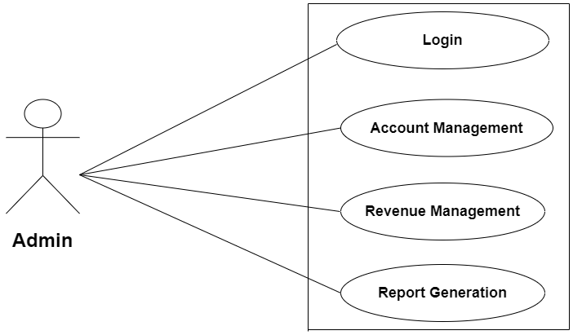

*Fig. Use Case Diagram for Admin*

1. In Admin use case diagram Admin is the Actor.
2. Admin can handle following use cases:
3. Login
4. Control Accounts
5. Revenue Management
6. Report Generation